Add a new Indirect activity category:

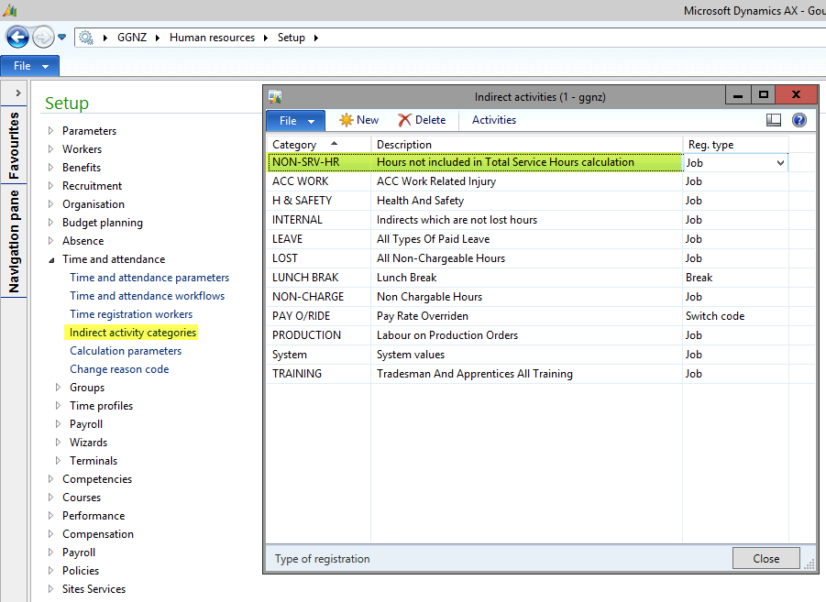

Add the following activities to the new Indirect activity category:

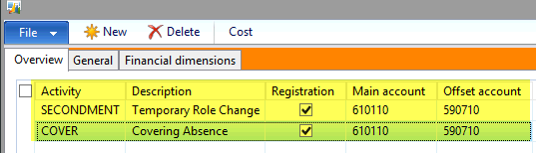

Remove the current Absence type of SECONDMENT:

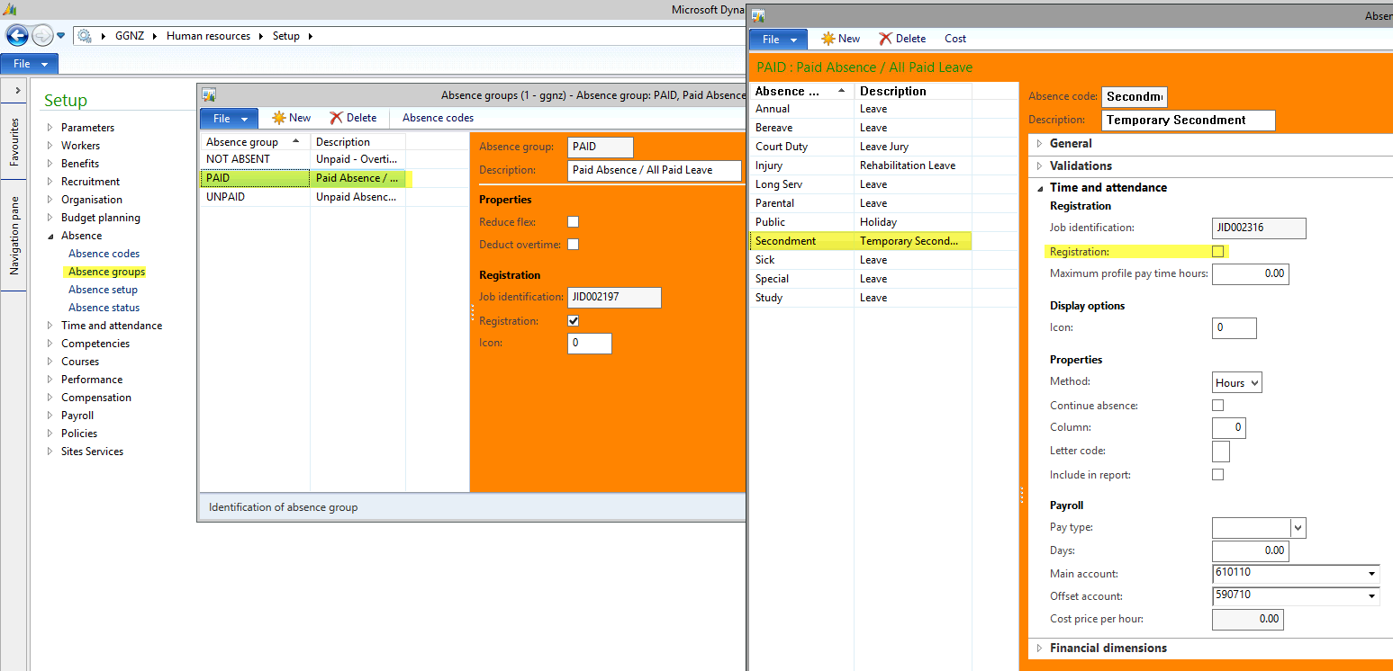

Add a new Indirect activity of SUPPORT:

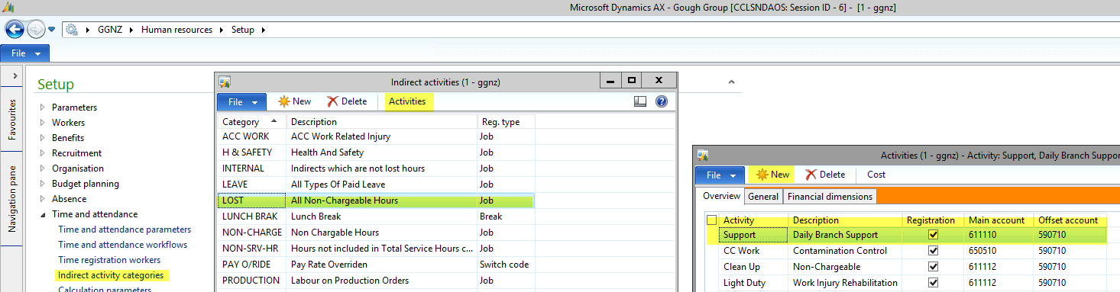

Remove the Indirect activity STAND IN:

